LAB 5 Vulkan

Introduction
Great job! Reaching this point is no easy task. You now have seen many of the fundamentals of the Vulkan API.
While we will still provide you with some guidance where necessary; You won’t find a giant list of TODOs: in the code or even be provided with a template project anymore. Knowledge of how-to setup your lab repo and how to research an API is something you are expected to carry forward from your previous assignments.
Now that you have some experience with a simple model format (OBJ) we are going to be upgrading to a much more modern format with all the bells and whistles (GLTF). This assignment will be the beginning of that process.

LAb 5

SECTION A | 25% - PROJECT SETUP & LoaDING the GLTF

Task A1
Get started by just setting up your project. Just copy the lab 3 starting files as the base code. (Lab 3 has a Z-buffer)
I recommend you delete all the TODO: comments from the base code so it doesn’t confuse anything later.
Make sure you edit and re-run the CMakeLists.txt file to accurately name your project solution. Edit the window title bar and background color to be something different as well:
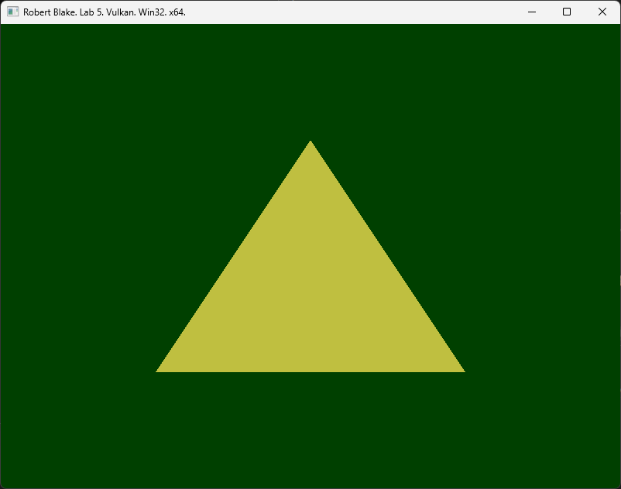
Tip: It’s possible to modify the application icon if you are feeling bold. Give it a shot if you want an extra challenge.

task A2
Include the Tiny GLTF library in the CMakeList.txt file.
If you look carefully in CMakeLists.txt, you will see how it searches the folder for certain files.
To make use of the TinyGLTF loading library, extend the project to search its folder.
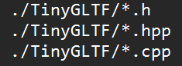
After saving the CMakeLists.txt file and recompiling, Visual Studio should prompt you to reload the project. (Do so)
Once the project includes the above files, #include the loader and make an instance of the class in Renderer.
IMPORTANT: When including TinyGLTF it does expect you to declare some #defines before everything in the library will work/link properly (Similar to Gateware.h). Unlike Gateware though, these defines tell the library where to copy the implementation so you should only ever do this inside one cpp file. (others can still include it though)
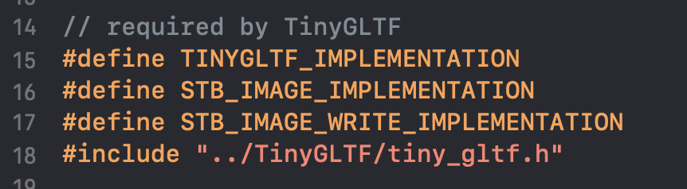

task A3
Use the TinyGLTF library to load the rudimentary GLTF from file. (Use it to load the included “triangle.gltf”)
https://github.com/syoyo/tinygltf?tab=readme-ov-file#loading-gltf-20-model
The above link shows you how to do this. This should be one of the first things you do during initialization.
To showcase the loader is working, print some information about the 3D model to the console.
Tip: Try to find & print some of the info you can see by opening the .gltf file in notepad or visual studio.

LAB CHECKPOINT | MANUAL COMMIT | DO NOT SKIP
To receive credit for your assignments, you must manually commit to your Repo 4 times (Once at the end of each Part/Section). If you skip this commit (or disable auto commits) you will not receive credit for the previous section.
- Change the lab’s Title Bar so it says where you are in the lab.
  - For Example: “John Smith – Lab 1 – Part 1 Complete”
- Take a Screenshot of the lab window running showing your work. (Windows Key + Shift + S)
- On Windows the screenshot is in your clipboard, open MS Paint and (Ctrl + V) to load it in.
- Save the image with the same name as your title bar in the root folder of this repository.
- Open GitHub Desktop for this repo. You should see the new image as a pending change.
- Create a commit message with the same name as the title bar & commit your changes.
If this section is not perfect but you need to continue forward, you must still do this to get partial credit!

section b | 50% - uploading the gltf geometry data

task b1
As discussed in class, the GLTF holds all geometric data in one giant block of memory with formats and offsets encoded in the file. This means the index buffer and vertex buffer are combined.
Traditionally, we would need to process this data and split it into multiple data sets for submission. However, Vulkan supports a very flexible resource system. Which means if Vulkan knows where data is (and how it’s formatted) it can use it.
To create a unified vkBuffer, just OR | both bit flags for VERTEX & INDEX together when creating it. This tells Vulkan you can use the one buffer for both data sets.
I suggest renaming/merging functions like CreateVertex… and CreateIndex… Into CreateGeometry…
Once you swap over to using this buffer, things may disappear, but that is to be expected until we adjust rule of 3.
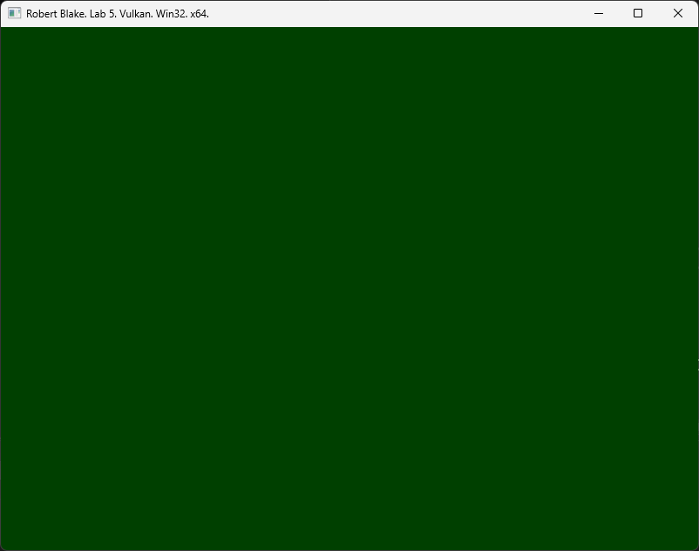
Tip: Check the “Day 2 Debugging” slides for info on how to properly access and copy raw data from an std::vector.

task b2
Even though our starting model is very simple, pretty much all GLTF data is going to use an index buffer.
Bind the new unified index buffer & switch to using vkCmdDrawIndexed() to draw all the indices in mesh 0.
Look inside the GLTF file and make a note of what format the index data uses, and where exactly it starts in the unified vertex + index buffer.
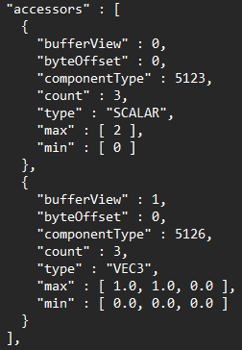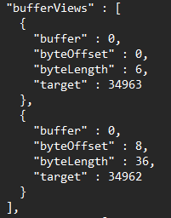
This information is critical to know/apply when binding the unified buffers to the graphics pipeline.
Never hard-code this information. Always grab it directly from the TinyGLTF Model object.

task b3
Now we can adjust the rule of three, starting with the vertex attributes. Note the “type” of the buffer view above.
A commonly missed part of the rule of three is the vertex stride. Be sure to account for that change as well.

task b4
Complete the rule of three adjustment in the vertex shader. Then view in RenderDoc:
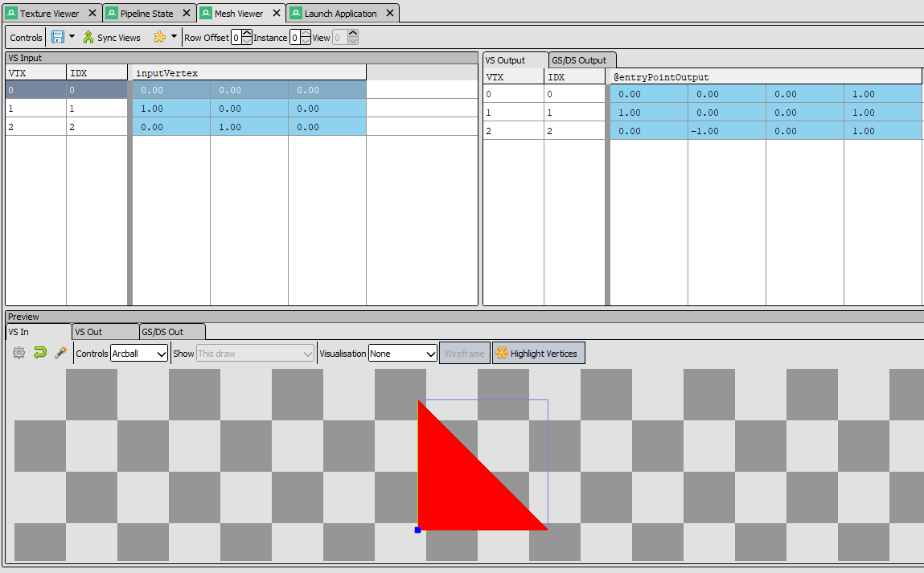
You may not be able to see it on screen, but the triangle should be working fine in the mesh viewer.

task b5
GLTF geometry uses a front-face COUNTER_CLOCKWISE winding order. Adjust the rasterizer stage so that the incoming triangle is not culled/rejected automatically. This optimization is called back-face culling.
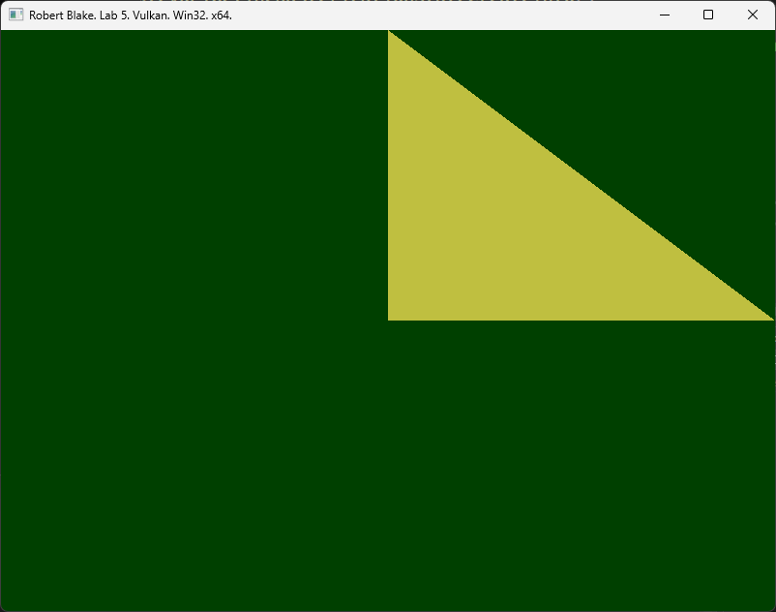

LAB CHECKPOINT | MANUAL COMMIT | DO NOT SKIP
To receive credit for your assignments, you must manually commit to your Repo 4 times (Once at the end of each Part/Section). If you skip this commit (or disable auto commits) you will not receive credit for the previous section.
- Change the lab’s Title Bar so it says where you are in the lab.
  - For Example: “John Smith – Lab 1 – Part 1 Complete”
- Take a Screenshot of the lab window running showing your work. (Windows Key + Shift + S)
- On Windows the screenshot is in your clipboard, open MS Paint and (Ctrl + V) to load it in.
- Save the image with the same name as your title bar in the root folder of this repository.
- Open GitHub Desktop for this repo. You should see the new image as a pending change.
- Create a commit message with the same name as the title bar & commit your changes.
If this section is not perfect but you need to continue forward, you must still do this to get partial credit!

section c | 75% - Game Ready GLTF & Format Consistency

task c1
Import the triangle.gltf model into the Blender 3D modeling software. We will be using Blender to homogenize GLTF 3D models of various data combinations we may come across. This way, we won’t have to write a bunch of branching code. For Example: GLTF allows for a variety of different vertex formats, however that can make writing consistent rendering code a challenge, especially in the time frame we have.
If we were writing a tool, then supporting a variety of kinds of vertex formats gives us more flexibility. With that said, we are focused on real-time video games, having a consistent and fast to load format makes the most sense.

task c2
To achieve this, we have provided the Custom_GLTF_Exporter.py Blender python script. To use it, you can copy it into the Script Tab in Blender and run it once. This will install the exporter; you should see it in the list of available exporters after you run the script. (It is also possible to permanently install the exporter if you wish)
Export the model (repo Models folder) to a different GLTF file (ex: blender_triangle.gltf) using the 3DCC exporter. Open the new GLTF file in a text editor to see how it has changed from the original version.
Tip: Take some time to review the python script, its main goal is to ensure consistency across different GLTF files.

task c3
Once you have your new version of the triangle, switch the loading code over to using it.
When you do this, it may no longer Draw. This is somewhat expected since our 3DCC exporter produces a much more robust vertex format that we will be using from here on out.
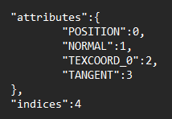
This format contains everything we need for more advanced rendering techniques.

task c4
As you can probably tell, the Rule of Three is no longer for just a 3-float position component.
Edit the rule of three to handle the newly exported 3DCC GLTF vertex format:
Adjust your Vertex and Fragment Shaders to input/output the new attributes.
Edit the VkVertexInputBindingDescription so it supports 4 descriptions instead of 1.
Add 3 more VkVertexInputAttributeDescription(s) that utilize the 4 new bindings.
You may have noticed tinygltf::BufferView(s) have an offset member to where the data is actually stored in the unified buffer. In Vulkan, you don’t specify these offsets during pipeline setup. Instead, go to where you are binding the vertex and index buffers before drawing and use it there.
Keep in mind that each vertex attribute in the unified buffer is split-up (aka: non-interleaved data):

This means each attribute starts at a different location in the buffer and must be accurately offset during binding. Once you get this setup correctly, your vertex assembly stage should look like this:
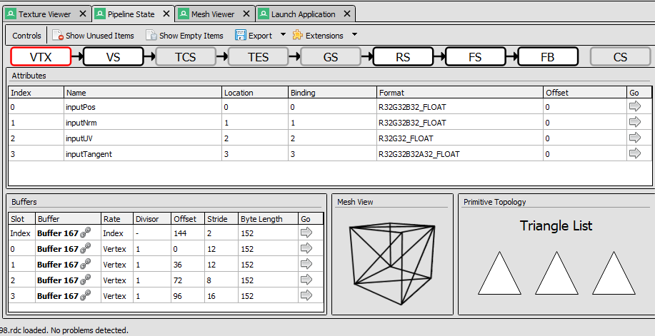
Again. Do not hard code the offsets/strides/lengths of the Buffers. Otherwise, no other 3D models will work.
NOTE: RenderDoc will NOT debug incoming attributes unless they are passed into/used in the shader.
Tip: The tinygltf::Accessor class has a built-in ByteStride() function to help you calculate it for each description.
Hint: vkCmdBindVertexBuffers() takes an array of offsets and a matching array of vkBuffers.

task c5
Confirm that your triangle appears properly in RenderDoc (like it did before) and that it draws correctly:
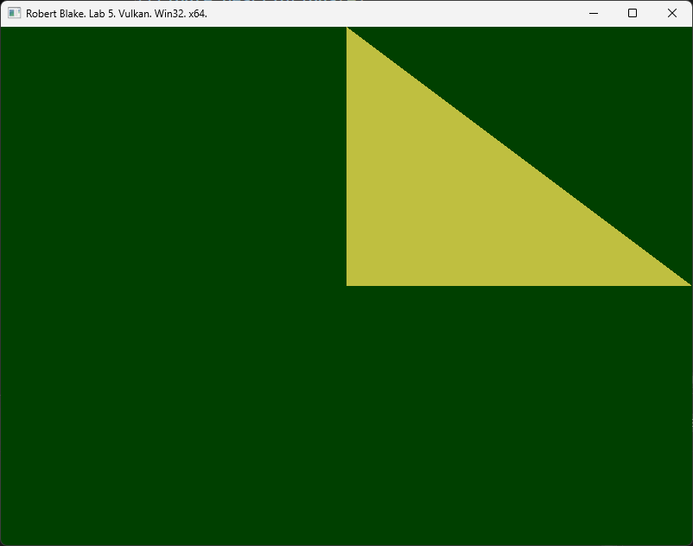

LAB CHECKPOINT | MANUAL COMMIT | DO NOT SKIP
To receive credit for your assignments, you must manually commit to your Repo 4 times (Once at the end of each Part/Section). If you skip this commit (or disable auto commits) you will not receive credit for the previous section.
- Change the lab’s Title Bar so it says where you are in the lab.
  - For Example: “John Smith – Lab 1 – Part 1 Complete”
- Take a Screenshot of the lab window running showing your work. (Windows Key + Shift + S)
- On Windows the screenshot is in your clipboard, open MS Paint and (Ctrl + V) to load it in.
- Save the image with the same name as your title bar in the root folder of this repository.
- Open GitHub Desktop for this repo. You should see the new image as a pending change.
- Create a commit message with the same name as the title bar & commit your changes.
If this section is not perfect but you need to continue forward, you must still do this to get partial credit!

section d | 100% - High Poly Mesh, 3D Camera & Lighting

task d1
In the last section we will be adding a more detailed 3D model. Once that’s in, we will enhance the application by porting over the camera and lighting code from last week.
In Blender, import 3D model file “Bebe.glb” or generate your own model at: https://lumalabs.ai/genie?view=create
Export it from Blender, using our custom 3DCC exporter like we did for the basic triangle.
This will guarantee our new model’s vertex format is consistent with the rendering code we just wrote.
Take note of the exported Textures folder. We won’t be using it in this lab, but it will become the focus of next lab.

task d2
Confirm the new mesh is loading both visually and in RenderDoc:
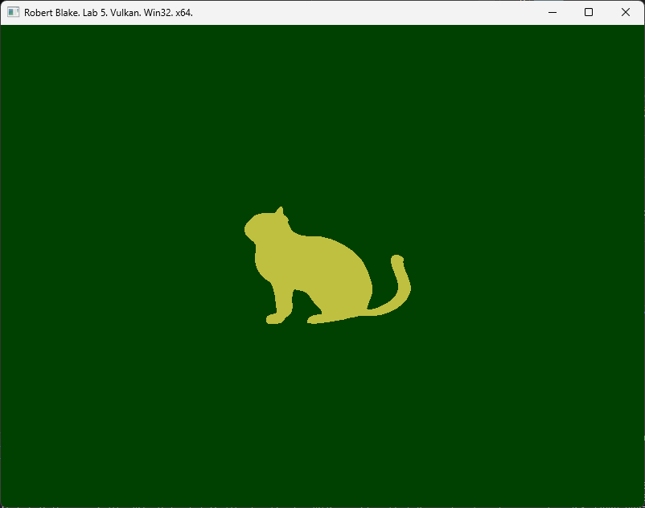
If you didn’t hard-code anything in a prior step, then the geometry should render correctly. Some models may not fully fit inside NDC Space, but you will still be able to preview their geometry in RenderDoc just fine.
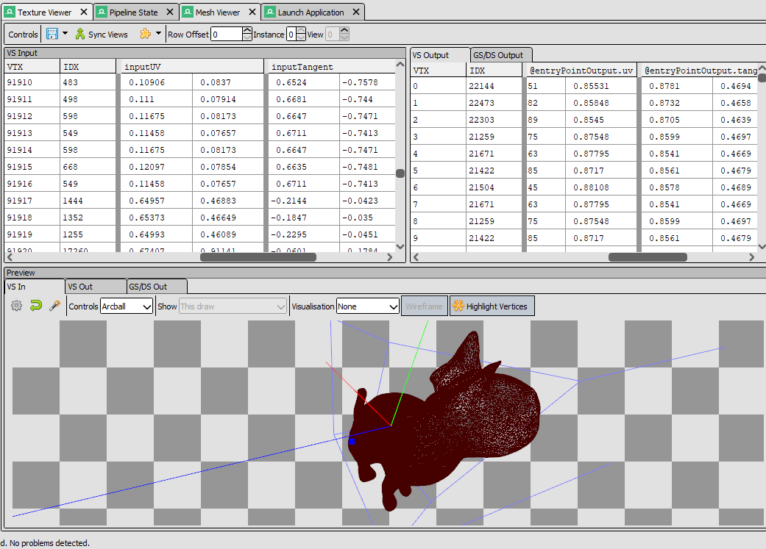
Our AI 3D model is quite high poly, but that’s alright we are running Vulkan.

task d3
Carefully port over the 3D matrix & uniform buffer code from lab 3.
This is a good time to do a manual commit or GIT Tag so if you seriously break something you can revert.
- VM, PM, Uniform Interfaces, Descriptor Interfaces, SHADER_VARS in C++ & HLSL, Camera.h
Remove any world matrices, we will just assume all meshes are at identity for now.
You will need to bring the code for allocating the uniform buffers and adjusting CreatePipelineLayout().
Call the camera code and be sure to update the uniform buffer each frame:
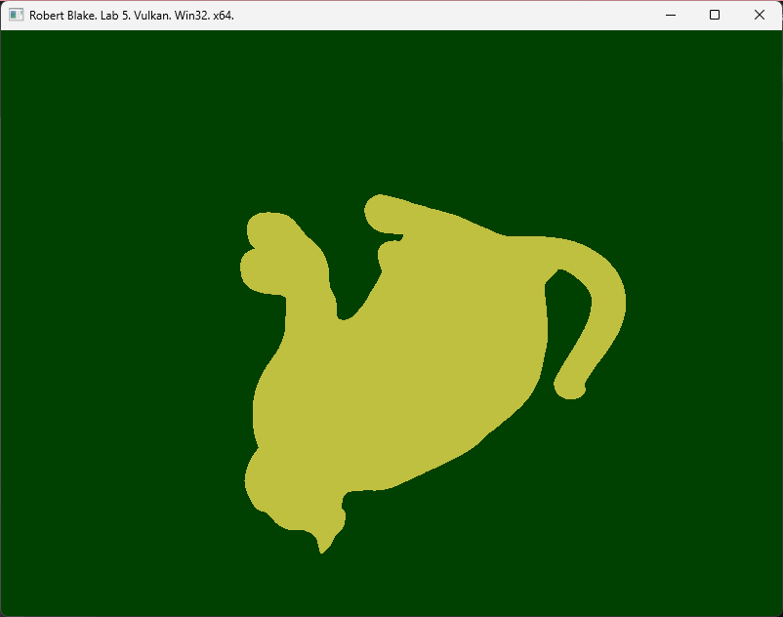
Default camera starts at the origin. Move the camera backwards and you will notice the cat is upside down.

task d4
The starting template code you used may still be automatically inverting the Y in the shader. Either disable the flip with a Vulkan projection or use a DirectX projection with the Y still flipped. (This is a shaderc compiler setting)
After fixing the camera code or adjusting shader compiler settings:
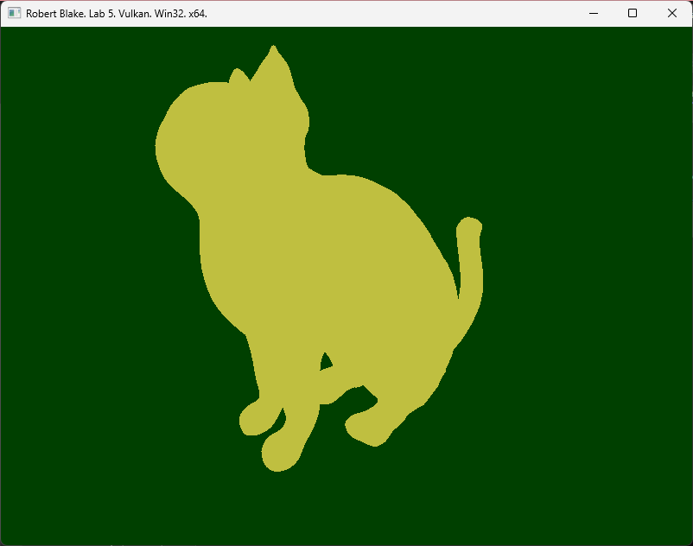
You should now have full 3D camera control of your GLTF scene!

task d5
Port the lighting code from lab 4, this should be mostly shader work. You will notice there are no more OBJ_ATTRIBUTES or other “Classic” material information in the file. Because this is a PBR or “Modern” style of material, all that info is stored in textures.
We will address textures and modern materials in the next lab assignment. For now, just hard-code the following classic material in the Fragment Shader:
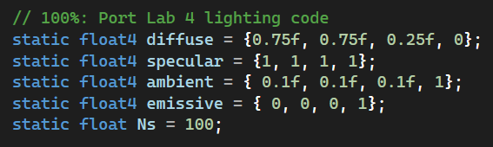
You will however need to transfer the sun’s lighting info (directional light) and the camera’s position to the SHADER_VARS struct for this to work. Once you do so, the rest of the code should port without too much issue.
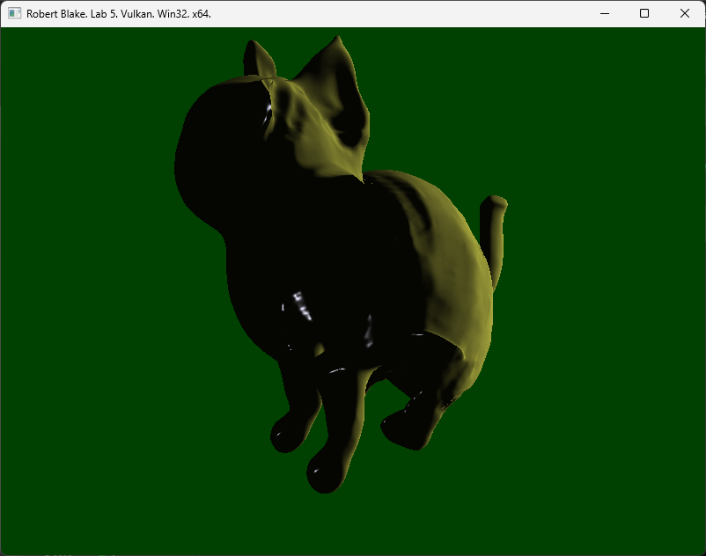
Once you get the code ported over and running it may look rather strange…
This is because we are looking at the inside of the 3D model. If you recall, we originally had to change the winding order of the rasterizer pipeline stage to see our initial triangle.
Now that we are working with our custom exporter, we can switch back to clockwise triangles. This technically not correct, but it will work for now until we can incorporate world matrices to account for right-handed coordinates.
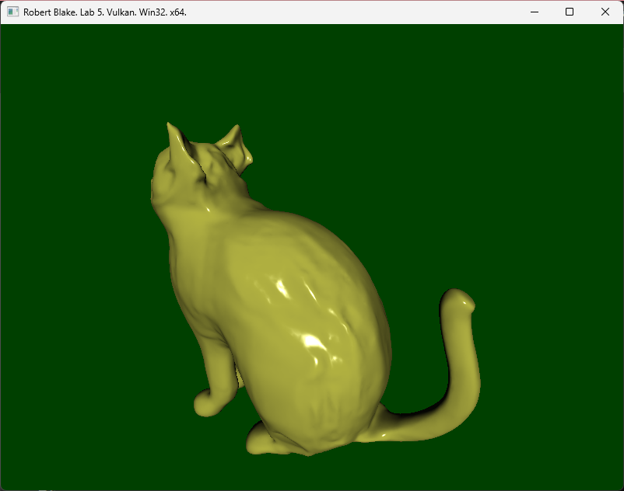
That is much more like it. Don’t mind the odd (slightly melty) geometry, that is just an artifact of the early 3D AI modeling tool used to generate this 3D model. That will improve drastically in the future, I am sure.
As you fly around make sure the Specular highlights shift with the camera. If they do not, that is likely because you are not updating the world space camera position in the shader properly.
Feel free to adjust/play with the lighting variables to make sure everything works as expected.
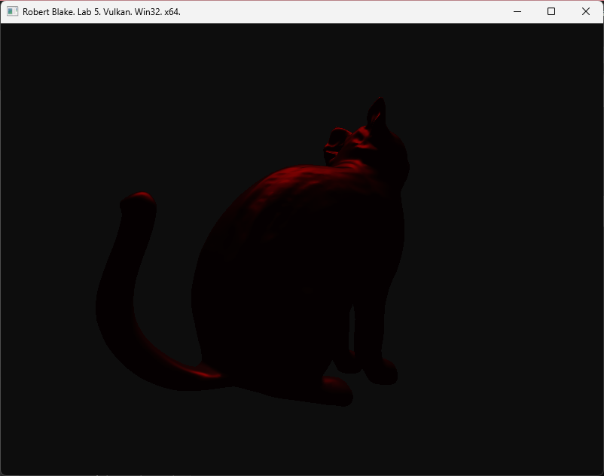
Just Messing About: Red overhead light reflecting off a shiny Onyx cat statue.

LAB CHECKPOINT | MANUAL COMMIT | DO NOT SKIP
To receive credit for your assignments, you must manually commit to your Repo 4 times (Once at the end of each Part/Section). If you skip this commit (or disable auto commits) you will not receive credit for the previous section.
- Change the lab’s Title Bar so it says where you are in the lab.
  - For Example: “John Smith – Lab 1 – Part 1 Complete”
- Take a Screenshot of the lab window running showing your work. (Windows Key + Shift + S)
- On Windows the screenshot is in your clipboard, open MS Paint and (Ctrl + V) to load it in.
- Save the image with the same name as your title bar in the root folder of this repository.
- Open GitHub Desktop for this repo. You should see the new image as a pending change.
- Create a commit message with the same name as the title bar & commit your changes.
If this section is not perfect but you need to continue forward, you must still do this to get partial credit!

Summary
Great job! You have now been introduced to the GLTF model format. Even though we are only using it to draw geometry right now, it can do quite a bit more than that. Materials, Textures, Matrix Hierarchies, Animations and more are available in this industry standard 3D format.
In the next lab assignment, you will explore using the texture data referenced in the GLTF file to further enhance your understanding of 3D rendering.

Resources
If you want to be a programmer, you must learn to read (and eventually write) API documentation. Period. In this section I have included links to said documentation and some handy reference books. Have them open, use them.

Vulkan API
https://vulkan.lunarg.com/doc/view/latest/windows/apispec.html
https://www.khronos.org/files/vulkan11-reference-guide.pdf
ebooks.fullsail.edu (if the link does not work directly, copy it to your browser)
https://learning.oreilly.com/library/view/vulkantm-programming-guide/9780134464701/
https:/github.com/SaschaWillems/Vulkan (will not transfer directly, but you can study the code for some insight)
https://github.com/KhronosGroup/Vulkan-Guide (nice overview of more specific resources)

HLSL High Level Shading Language
https://docs.microsoft.com/en-us/windows/win32/direct3dhlsl/dx-graphics-hlsl-reference
Note: The above docs often refer to Direct3D APIs. Modern Vulkan can also use the language. You should just study the syntax of the language when using it with Vulkan as other things like compiling are done differently.
https://shadered.org (opensource HLSL & GLSL shader IDE, excellent for learning about modern shaders)
https://docs.microsoft.com/en-us/visualstudio/designers/shader-designer?view=vs-2019 (Visual Shader Designer)
Note: The VS Shader Designer is handy for prototyping complex shaders once you are more familiar with HLSL.

Gateware
We will be using this API occasionally throughout these assignments for simplicity’s sake. Gateware is a powerful cross-platform API often contributed to by students here at Full Sail just like you. (Designed for 3D Engine builders)
https://gateware-development.gitlab.io/gcompiler/index.html (Official Documentation)
Tip: use the “--->” triple-dash operator on any Gateware proxy to have intellisense show you the actual arguments.

FAQ
- How do I know if I am using the Vulkan API correctly?
  - Aside from reading the docs and making sure the code compiles, we have enabled run-time debug output in the Vulkan API. Be sure to pay close attention to the console window when running the program. Any non-fatal mistakes you make will be reported by the Vulkan validation layer and printed there.
- Visual Studio doesn’t seem to be detecting the errors in my shaders, how am I supposed to code like this?
  - Carefully. Believe it or not it was not so long ago that things like intellisense, syntax highlighting and auto complete were not a common thing, especially in shader languages!
  - The way to know if your shader will compile is to… compile it!(right?) Shader languages must be compiled into machine instructions just like C++. If you study the code that loads the shaders you will see that compiling is part of that process.
  - Vulkan uses a binary intermediate language called SPIR-V that higher level shader languages like HLSL and/or GLSL must be compiled into. If there are any issues when converting your code to SPIR-V the shaderc compiler will note the error and I added code to print it to the console. Keep your eyes on it.
  - It is possible to have visual studio compile your HLSL code - but the output is not compatible with Vulkan, and it cannot compile Vulkan-specific features like push constants. Once your shaders get complex, I recommend using a dedicated shader IDE like ShaderEd.
- I have no compiler errors or run-time errors, yet nothing seems to be drawing. What do I do now?
  - Check over your code carefully to ensure you did not miss anything obvious such as having the wrong shader or geometry assigned to a pipeline. (or just setting up your vertex data wrong)
  - Problems like this can be difficult to track down, mainly because your C++ code cannot really see what is happening on the GPU. You can download a third-party tool called RenderDoc to dig much deeper.
  - If you are still lost, talk to an instructor. We can often point you in the right direction or help you make sense of the error messages you encounter until you get more comfortable dealing with them yourself.
- Is possible to do these assignments without Gateware? I prefer to do things from the ground up.
  - Technically yes, practically no. While someone(Derrick Ramirez) did originally have to write the Vulkan interface to Gateware, setting up a modern Graphics API like Vulkan or Direct3D12 from scratch takes a substantial amount of time. Its just something we don’t have enough time for in a one month course.
  - If you still really want to learn how to initialize a 3D API with no dependencies, there are plenty of online resources out there(including a few of my own) on how to do exactly that once you complete this course.

